**AI IN BLOCKCHAIN**

**SUBMITTED BY:**

Krishnandan sah kanu

12106329

RK21ANB46

Tejas thukral

12209083

RK21ANB70

Jaya Chandra naidu

12112584

RK21ANA22



**School of computer science and engineering**

**Lovely Professional University**

**Phagwara, Punjab (India)**

**Abstract**

There has been increased interest in applying artificial intelligence (AI) in various settings to inform decision-making and facilitate predictive analytics. In recent times, there have also been attempts to utilize blockchain (a peer-to-peer distributed system) to facilitate AI applications, for example, in secure data sharing (for model training), preserving data privacy, and supporting trusted AI decision and decentralized AI. Hence, in this paper, we perform a comprehensive review of how blockchain can benefit AI from these four aspects.

**Introduction**

Artificial intelligence (AI), an important branch of computer science, underpins the research and development of the theories, methods, technologies, and applications for simulating, extending, and expanding human intelligence. While AI was first proposed in 1956, the interest in AI probably increased significantly after AlphaGo (an AI-based computer program) defeated Lee Sedol, the world Go champion. AI has been applied in diverse settings, ranging from healthcare [1–4] to drug discovery [5] to (medical) image recognition [6–9] to automated driving [10, 11] and so on.

Compared with AI, blockchain is a relatively young technology as it was first proposed by Nakamoto and Wright in 2008 [12]. Blockchain, a peer-to-peer distributed system, ensures tamper-proofing through the underlying hash algorithm and time stamp technology. The privacy of data stored on the blockchain is guaranteed by using some cryptographic algorithms. Through the use of smart contracts, the program can be executed automatically to ensure the credibility of the execution results. Through consensus mechanism and distributed ledger technology, all nodes can participate in bookkeeping and verify the transactions. The market capitalization of Bitcoin as of February 20, 2020, was approximately 175 billion dollars [13]. As shown in Table [1](https://www.hindawi.com/journals/scn/2021/6126247/tab1/), these characteristics of blockchain may overcome the challenges faced by AI.

**Blockchain Technology**

the architecture of blockchain mainly comprises the data layer, network layer, consensus layer, incentive layer, contract layer, and application layer, see also Figure 1. the data layer mainly focuses on the data structure, including the hash function, digital signature, Merkle tree, asymmetric encryption, and other technologies. the most important structure of the data layer is the block, and the block structure is shown in Figure 2. A block consists of both the block head and the block body. the block header contains the Merkle root, timestamp, and hash value of the current block and previous block. the block body mainly includes transaction information and Merkle tree. Each transaction is signed by the transaction’s initiator and then processed and verified by the miner. the verified transaction is embedded in the block. the hash value of every transaction is combined in pairs to calculate the hash, and then, the resulting hash value is combined in pairs to calculate the hash value again until the Merkle root, which is recorded in the block header. Every change to the information about every transaction stored on the blockchain affects the Merkle root. In this way, the tamper-proofing of blockchain can be realized. Every block additionally stores the hash value of the previous block and timestamp, resulting in a time sorted chain.

Table: Blockchain for AI

|  |  |  |  |
| --- | --- | --- | --- |
|  | Blockchain | Ai | Blockchain for Ai |
| Data | 1. Trust 2. Security | 1. Ensure high quality data 2. Secure data sharing | Blockchain supports AI in terms of facilitating trustworthy data and secure data sharing |
| Algorithm | 1. Automation 2. Immutability 3. Traceability | (i) Need a credible training process | Model training is automatically executed by the smart contract, which greatly improves the credibility of the training results |
| Computer power | 1. Decentralization 2. Trust 3. Traceability | i) Centralized AI-high computing cost | The decentralized blockchain structure provides distributed computing power for AI |

**Application**

1. **Data sharing:**

Data is the most important resource of AI. The quantity and quality of data directly affect the accuracy of AI classification results. But, in the process of sharing data, there are some problems. First, the data needed for training is controlled by different stakeholders, and they cannot trust each other. It is difficult to authorize or verify the data. Second, there may be malicious users sharing malicious data for certain purposes. There are already some blockchain-based solutions to these problems.

The work in [43] proposed a blockchain-based, decentralized, and untrusted data market. IoTs’ equipment providers and AI solution providers can carry out transparent interaction and cooperation through this platform and realize user registration, data upload, data search, purchase, payment, and feedback through smart contract.

1. **Privacy Preserving:**

Privacy preserving is also a key issue. The protection of such personal sensitive data during the sharing process is difficult, which will prevent users from sharing their data. Additionally, the data should be completely controlled by the owner, but now users need to send their own data to the service provider when using the service, resulting in the abuse of personal data by some big companies.

In [53], blockchain has been used to construct a trustworthy and secure data platform across numerous data sources, and IoT data is stored on the blockchain through Paillier encryption. IoT data providers’ sensitive information and SVM model parameters are confidential. Data providers can update the gradient without knowing the model parameters through homomorphic encryption. In this way, collusion between data providers and data analysts can be avoided. Combined with the tamper-proofing of blockchain, a secure SVM training algorithm is established to address data integrity and privacy issues.

1. **Trusted AI Decision:**

Different organizations create, train, and use models of machine learning and AI. The entities that train the model are different from the entities that provide the data. Failure to pay attention to data used in training the model might lead to improper outcomes. Meanwhile, the trained model might have some restrictions if we employ biased data. All of the above operations are opaque to users, and users cannot trust the model they are using. Therefore, we need a mechanism to record the entire process of AI (model creation, training data, and training process), and these records cannot be changed or forged. Blockchain, a platform that enables numerous participants to trustly share data, has the characteristics of tamper-proofing and transparency, which are very suitable for recording the whole process of machine learning.

1. **Decentralized Intelligence:**

A vast quantity of IoT data has been created with the fast evolution of the IoTs. Through the AI service, we can obtain the learning results and models from the massive IoT data. In order to perform complex model training tasks, collaboration with multiple devices is normally needed owing to the distribution of IoT devices and edge computing devices. There are two ways to collaborate here. First, different IoT devices or edge devices need to share data for complete data analysis and prediction (such as intelligent monitoring, monitor in different regions needs to share data). Second, different IoT devices or edge devices share their own learning models and then aggregate the models, that is, federated learning.

**Advantages**

## **Control and explain AI decisions:**

Humans can find it difficult to comprehend AI-driven decisions. This is mostly because AI solutions autonomously analyze huge sets of variables to determine those that are essential to reaching the overall goal.

1. **Improve credibility:**

The blockchain has lots of benefits over other types of data storage. But the main challenge today is collecting input data to train a neural network. Users publicly share massive amounts of data online, but the quality of all this unstructured data is far from perfect. Such well-known companies as Facebook and Google use many computational techniques to try to avoid collecting and storing faulty information. Adversarial attacks can also reach the internal stores.

1. **Improve Security:**

Blockchain-stored data is protected with built-in encryption mechanisms. A blockchain is efficient for recording personal data such as medical notes or individual recommendations. And data is what AI systems require in huge amounts — and regularly. Experts are now hard at work on algorithms and techniques that would enable AI to interact with encrypted data and not expose it in any way.

1. **Manage and Store huge Data:**

Although this benefit is related to improved security, we can’t pass it by. A distributed ledger can store encrypted data, while AI offers powers for managing that data productively. New use cases appear as a result. You may safely store personal information on the blockchain and distribute access to it.

1. **Control Blockchain more effectively:**

In terms of blockchain management, AI contain both human and computer capabilities. As swift as computers can be in their operations, manipulating blockchain data on hardware devices still requires intense processing power, mainly due to the encrypted nature of the data processed.

1. **Enhance the quality of smart contracts:**

Smart contracts were introduced not long ago, and they may not work as well as we would like. Artificial intelligence can easily check all smart contract decisions. We can see that smart contract technology is vulnerable to hackers and that it makes poor decisions influenced by outside factors. You may use AI or blockchain technologies to identify these factors and make the right decisions.

1. **Get easier access to shared Database:**

Many companies use a common database to successfully run their operations. For instance, banks prefer a common database because it allows them to verify the accuracy of data submitted by users and makes it easier to check credit histories.

**Disadvantages**

**1. Regulatory Challenges:**

Blockchain technology is still in its early stages, and there is a lack of clear regulations governing its use. This can result in regulatory challenges and uncertainty, as governments struggle to keep up with the rapidly evolving technology.

**2.Energy Consumption:**

The process of validating transactions on the blockchain requires a significant amount of energy, as it involves complex mathematical calculations. This can result in high energy consumption, leading to environmental concerns and increased costs.

**3.Scalability:**

Blockchain technology is still in its early stages and is not yet capable of handling a large volume of transactions. This can result in slow processing times and delays, making it difficult to scale the technology to meet the needs of a growing user base.

**4.Security Risks:**

While blockchain technology is highly secure, it is not completely immune to hacking and other security risks. If a majority of the nodes on the network are compromised, it can result in a 51% attack, enabling hackers to alter the blockchain and steal funds.

**Model**

**Bitcoin price prediction**: Bitcoin uses Blockchain concept which is peer-to-peer technology to operate with no central authority or banks; managing transactions and the issuing of bitcoins is carried out collectively by the network. Bitcoin is open-source; its design is public, nobody owns or controls Bitcoin and everyone can take part.

Data contain such as:

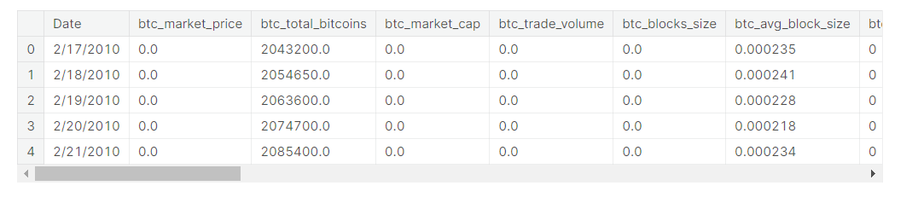

Code:

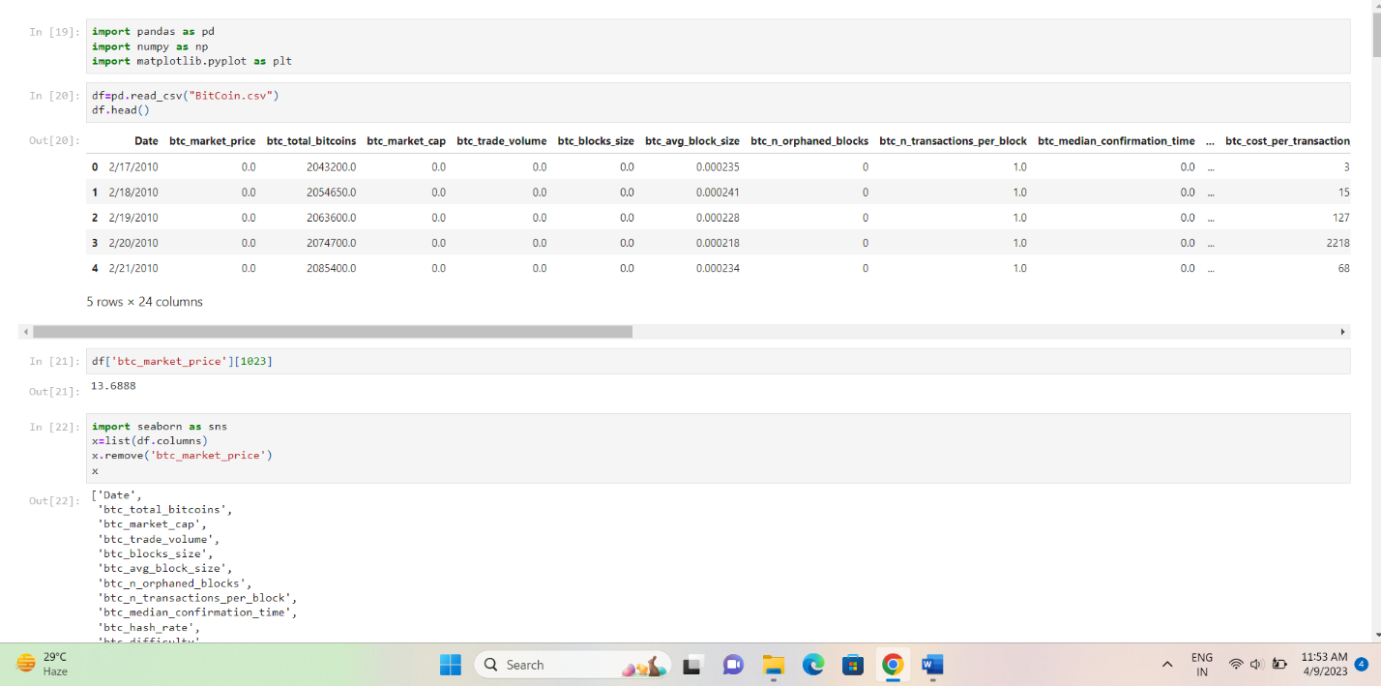

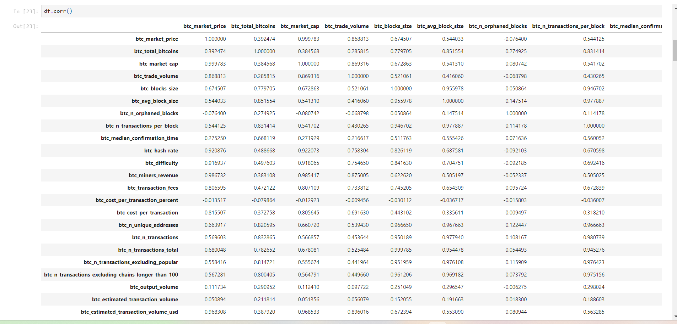

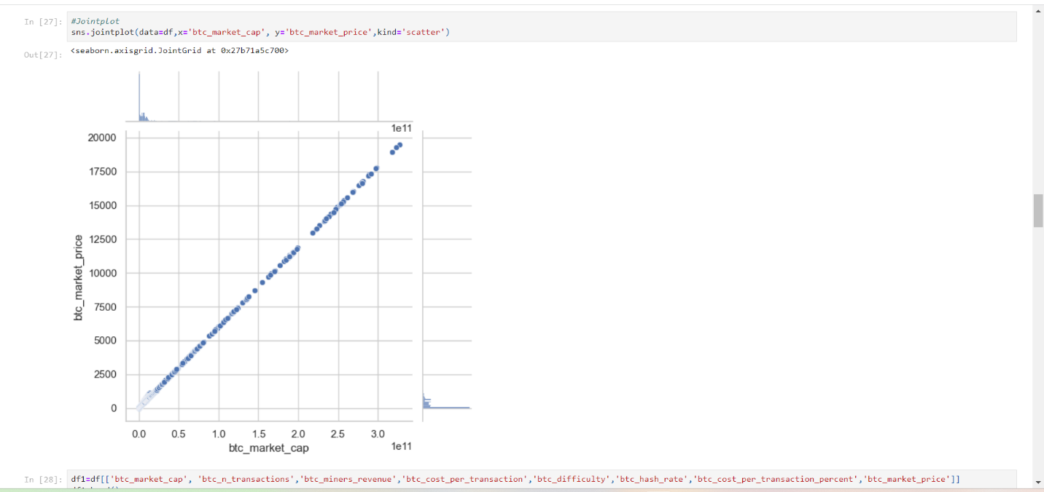

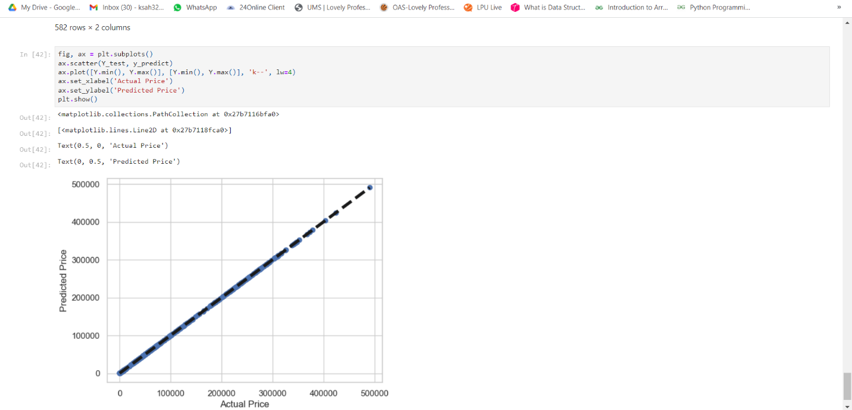

**Review**

# **Accounting and auditing with blockchain technology and artificial Intelligence:**

This paper surveys the published work on how blockchain technology will impact accounting in general, but AI-enabled auditing specifically. The purpose is to investigate how blockchain technology can improve transparency and trust in accounting practice and how professionals can use blockchain data to improve decision-making, based on the qualities of immutability, append-only, shared, verified, and agreed-upon (i.e., consensus-driven) blockchain data.

Hongdan Han, Radha K. Shiwakoti, Robin Jarvis, Chima Mordi, David Botchie

Brunel Business School, Brunel University London, UB8 3PH, United Kingdom

# **Semantic analysis of blockchain intelligence with proposed agenda for future issues:**

Integrating blockchain technology with artificial intelligence (AI) i.e., blockchain Intelligence makes an extremely powerful tool that solves many multidimensional problems in several domains. Blockchain technology has the potential to provide links to shared data, transactions, and records in a decentralized, safe, and reliable manner, including the information and decision-making capability of AI which makes machines similar as capable as humans. This study is intended to present an updated systematic review of the integration of Blockchain and AI in various application areas. We have studied and summarized more than 100 research papers to present an updated version of the review. We also discuss the future of Blockchain technologies with AI.

[Rashi Saxena](https://link.springer.com/article/10.1007/s13198-023-01862-y#auth-Rashi-Saxena),  [E. Gayathri](https://link.springer.com/article/10.1007/s13198-023-01862-y#auth-E_-Gayathri) & [Lalitha Surya Kumari](https://link.springer.com/article/10.1007/s13198-023-01862-y#auth-Lalitha-Surya_Kumari)

[International Journal of System Assurance Engineering and Management](https://link.springer.com/journal/13198) (2023)

# **Artificial Intelligence (AI), Blockchain, and Cryptocurrency in Finance: Current Scenario and Future Direction**

This paper is a review of research work done in FinTech that included technological innovation in finance in area such as the credit market (including Peer-2-Peer lending), insurance with a blockchain-assisted smart contract and payment systems (including cryptocurrencies). The paper provides a bibliometric review of FinTech in finance based on the published articles and journals in the Scopus database relating to 1,717 publications available between 1960 and 2021 onward. Furthermore, various software such as graphs and tables, Microsoft Excel to carry out frequency analysis, and VOSviewer for data visualization design illustrate technological impact in finance. This paper details the results utilizing standard bibliometric measures such as authorship, active institutions, citation analysis, document type, geographical distribution, keywords analysis, publication year, source type, source title and subject area. The findings proved that publications in this field are on constant augmentation in the last decades, especially in the previous six years from 2015, since the number of publications skyrocketing, leading by the USA and China, the FinTech study pioneers. The rising research in this area points out the technological impact on financial products and services, which ultimately affects human’s lifestyle in the new worldwide digital economy.

[Mosharrof Hosen](https://link.springer.com/chapter/10.1007/978-3-031-25274-7_26#auth-Mosharrof-Hosen), [Hassanudin Mohd Thas Thaker](https://link.springer.com/chapter/10.1007/978-3-031-25274-7_26#auth-Hassanudin_Mohd_Thas-Thaker), [Vasanthan Subramaniam](https://link.springer.com/chapter/10.1007/978-3-031-25274-7_26" \l "auth-Vasanthan-Subramaniam), [Hooi-Cheng Eaw](https://link.springer.com/chapter/10.1007/978-3-031-25274-7_26#auth-Hooi_Cheng-Eaw) , [Tat-Huei Cham](https://link.springer.com/chapter/10.1007/978-3-031-25274-7_26#auth-Tat_Huei-Cham)

Dosso, M., Aysan, A.F.: The technological impact in finance: a bibliometric study of fintech research. In: Bilgin, M.H., Danis, H., Demir, E., Mustafa, G. (eds.) Eurasian Business and Economics Perspectives: Proceedings of the 35th Eurasia Business and Economics Society Conference, pp. 193–209. Springer International Publishing, Cham (2022).

# **A critical analysis of the integration of blockchain and artificial intelligence for supply chain**

The integration between blockchain and artificial intelligence (AI) has gained a lot of attention in recent years, especially since such integration can improve security, efficiency, and productivity of applications in business environments characterized by volatility, uncertainty, complexity, and ambiguity. In particular, supply chain is one of the areas that have been shown to benefit tremendously from blockchain and AI, by enhancing information and process resilience, enabling faster and more cost-efficient delivery of products, and augmenting products’ traceability, among others. This paper performs a state-of-the-art review of blockchain and AI in the field of supply chains.

[Vincent Charles](https://link.springer.com/article/10.1007/s10479-023-05169-w#auth-Vincent-Charles),  [Ali Emrouznejad](https://link.springer.com/article/10.1007/s10479-023-05169-w#auth-Ali-Emrouznejad) , [Tatiana Gherman](https://link.springer.com/article/10.1007/s10479-023-05169-w#auth-Tatiana-Gherman)

Charles, V., Emrouznejad, A. & Gherman, T. A critical analysis of the integration of blockchain and artificial intelligence for supply chain. Ann Oper Res (2023).

**Integration of Artificial Intelligence and Blockchain Technology in Healthcare and Agriculture**

Over the last decade, the healthcare sector has accelerated its digitization and electronic health records (EHRs). As information technology progresses, the notion of intelligent health also gathers popularity. By combining technologies such as the internet of things (IoT) and artificial intelligence (AI), innovative healthcare modifies and enhances traditional medical systems in terms of efficiency, service, and personalization. On the other side, intelligent healthcare systems are incredibly vulnerable to data breaches and other malicious assaults. Recently, blockchain technology has emerged as a potentially transformative option for enhancing data management, access control, and integrity inside healthcare systems. Integrating these advanced approaches in agriculture is critical for managing food supply chains, drug supply chains, quality maintenance, and intelligent prediction. This study reviews the literature, formulates a research topic, and analyzes the applicability of blockchain to the agriculture/food industry and healthcare, with a particular emphasis on AI and IoT. This article summarizes research on the newest blockchain solutions paired with AI technologies for strengthening and inventing new technological standards for the healthcare ecosystems and food industry.

Prajjawal Pandit, Department of Computer Science & Engineering, Lovely Professional University, Phagwāra, Punjab, India

# **The ChatGPT Effect on AI-Themed Cryptocurrencies**

ChatGPT is an artificial intelligence (AI) chatbot that provides users with detailed responses and accurate answers to any questions. It has garnered significant attention after its launch in November 2022. We analyze the returns of AI-themed crypto assets around the launch and widespread attention towards ChatGPT. We reveal significant abnormal returns for AI tokens after the launch of ChatGPT, up to 41% over the course of two weeks. Moreover, 90% of tokens exhibit positive abnormal returns. This suggests that the attention towards ChatGPT and AI in general has transitioned to cryptocurrency markets, resulting in positive price effects for AI-related cryptocurrencies.

Ante, Lennart and Demir, Ender, The ChatGPT Effect on AI-Themed Cryptocurrencies (February 7, 2023).

**Conclusion**

We surveyed the existing literature to understand the potential applications of blockchain in AI. For example, we explained how the different characteristics of blockchain can be used in supporting data sharing, privacy preserving, trusted AI decision, and decentralized intelligence.

1. First, as a decentralized platform, blockchain enables data owners and data users to share or trade data in a peer-to-peer manner [23]. Because blockchain is transparent and immutable, it can minimize the potential for fraud in distributed data sharing or transaction.
2. In addition, the underlying cryptographic algorithms (hash algorithms, homomorphic encryption, threshold encryption, etc.) used to process data stored on the blockchain help ensure the confidentiality, integrity, and authenticity of sensitive data.
3. )e use of smart contracts to automate model creation, training, sharing, decision-making, and traceability on blockchain helps ensure the credibility of decision results.
4. Incentive mechanisms can be designed on blockchain to promote the cooperation of all participants in completing the AI training tasks.

In addition, we also identified a number of existing and emerging challenges, which will hopefully guide future research agenda.

**References**

[1] A. Madani, R. Arnaout, M. Mofrad, and R. Arnaout, “Fast and accurate view classification of echocardiograms using deep learning,” NPJ digital medicine, vol. 1, no. 1, pp. 1–8, 2018.

[2] A. Choudhury and O. Asan, “Role of artificial intelligence in patient safety outcomes: systematic literature review,” JMIR medical informatics, vol. 8, no. 7, Article ID 18599, 2020.

[3] H. Zerouaoui and A. Idri, “Reviewing machine learning and image processing based decision-making systems for breast cancer imaging,” Journal of Medical Systems, vol. 45, no. 1, pp. 1–20, 2021.

[4] S. Secinaro, D. Calandra, A. Secinaro, V. Muthurangu, and P. Biancone, “)e role of artificial intelligence in healthcare: a structured literature review,” BMC Medical Informatics and Decision Making, vol. 21, no. 1, pp. 1–23, 2021.

[5] E. Gawehn, J. A. Hiss, and G. Schneider, “Deep learning in drug discovery,” Molecular informatics, vol. 35, no. 1, pp. 3–14, 2016

[6] T.-H. Chan, K. Jia, S. Gao, J. Lu, Z. Zeng, and Y. Ma, “PCANet: a simple deep learning baseline for image classification?,” IEEE Transactions on Image Processing, vol. 24, no. 12, pp. 5017–5032, 2015.

[7] J. Frank, T. Eisenhofer, L. Sch¨onherr, A. Fischer, D. Kolossa, and T. Holz, “Leveraging frequency analysis for deep fake image recognition,” in Proceedings of the 37th International Conference on Machine Learning, ICML, Vienna, Austria, 13- 18 July 2020.

[8] C. M. Dourado, S. P. P. Da Silva, R. V. M. Da Nobrega, ´ P. P. Rebouças Filho, K. Muhammad, and V. H. C. De Albuquerque, “An open ioht-based deep learning framework for online medical image recognition,” IEEE Journal on Selected Areas in Communications, vol. 39, no. 2, pp. 541–548, 2020.

[9] O. J. H´enaff, “Data-efficient image recognition with contrastive predictive coding,” in Proceedings of the 37th International Conference on Machine Learning, ICML, Vienna, Austria, 13-18 July 2020.

[10] M. Bojarski, D. Del Testa, D. Dworakowski et al., “End to End Learning for Self-Driving Cars,” 2016, https://arxiv.org/abs/ 1604.07316.

[11] Y. Xing, C. Lv, X. Mo, Z. Hu, C. Huang, and P. Hang, “Toward safe and smart mobility: energy-aware deep learning for driving behavior analysis and prediction of connected vehicles,” IEEE Transactions on Intelligent Transportation Systems, vol. 22, no. 7, pp. 4267–4280, 2021.

[12] S. Nakamoto and C. Wright, “Bitcoin: a peer-to-peer electronic cash system,” vol. 2008, 2008.

[13] I. Shaikh, “Policy uncertainty and bitcoin returns,” Borsa Istanbul Review, vol. 20, no. 3, pp. 257–268, 2020